Ex. No: 2 | Web Technologies – Job Application Form
Date: 21-07-26

Objective:
Design and implement a client-side multi-step form validation system for an Online Job Application Portal using HTML, CSS, JavaScript, and Font Awesome icons. The application should begin with a User Registration Form. After successful validation of all registration fields, the user should be allowed to proceed to the Job Application Form. Upon successful validation of the job application details, an application submission success message should be displayed.
Code Implementation:
  - Index.html
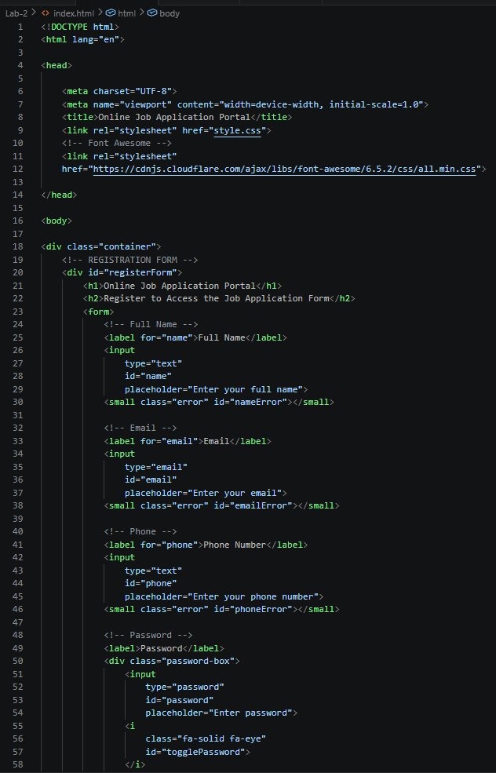
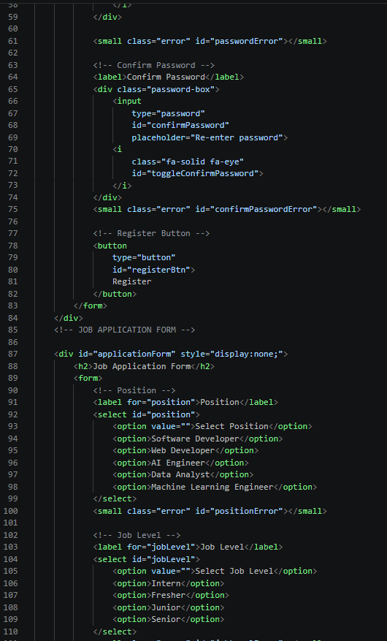

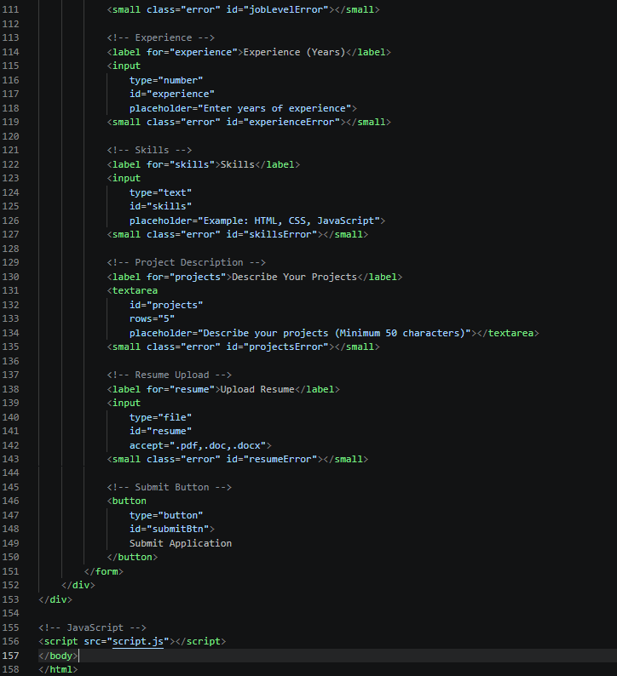

  - Style.css
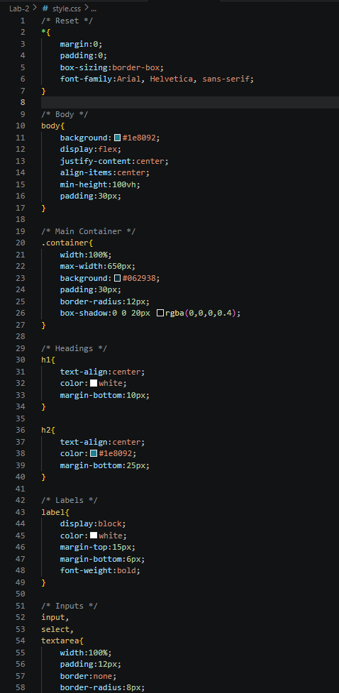
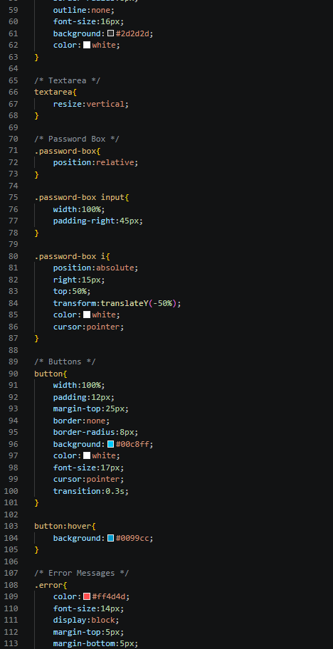
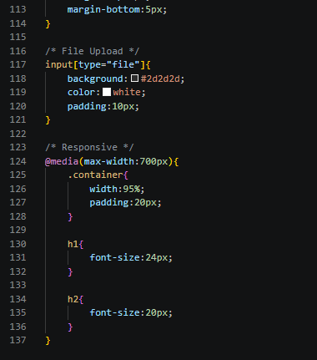
  - Script.js
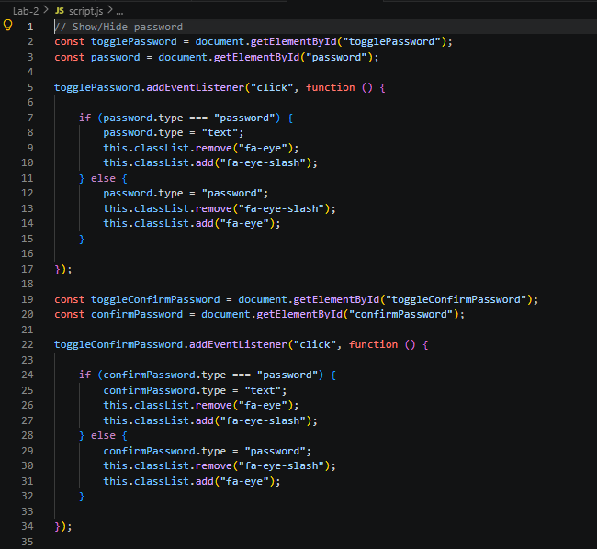
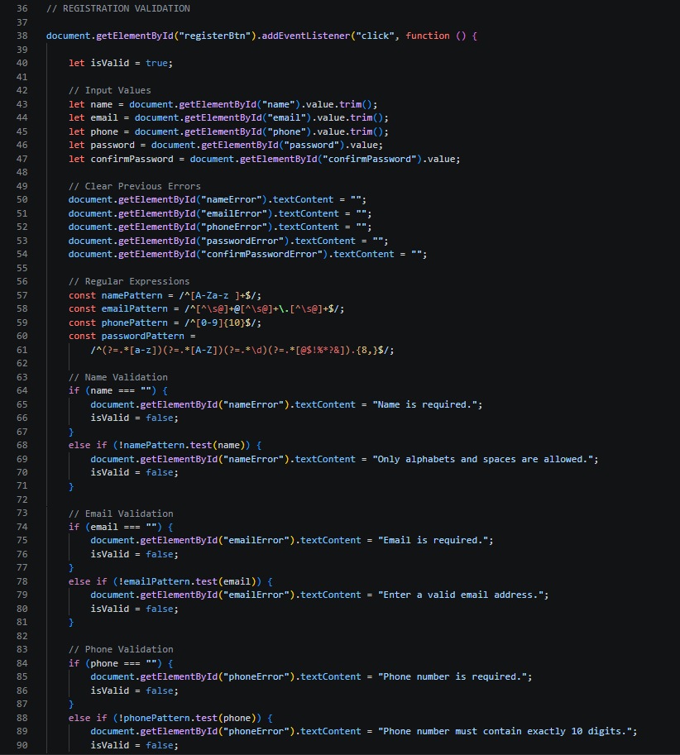

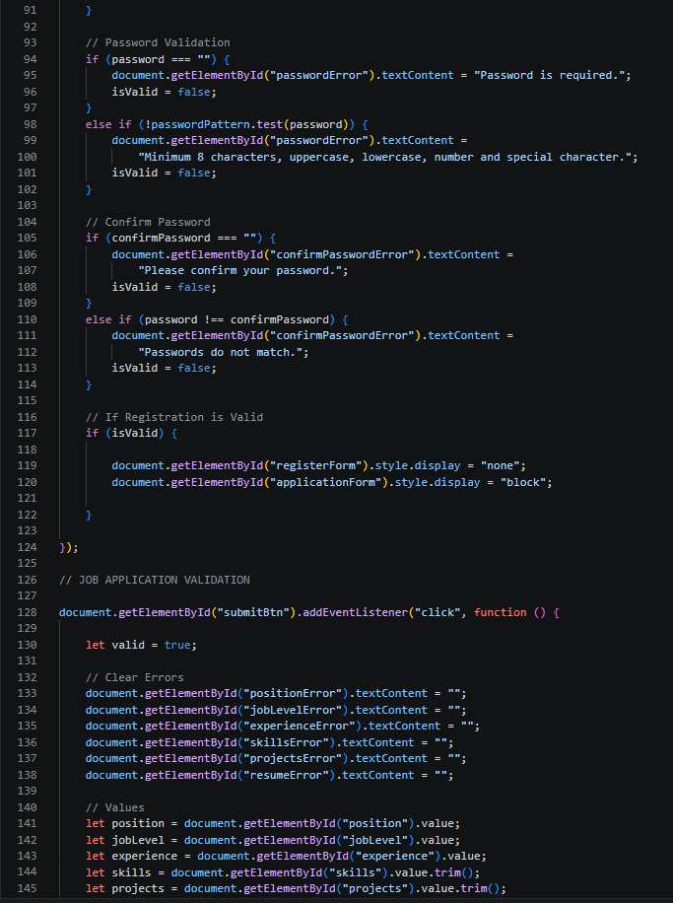

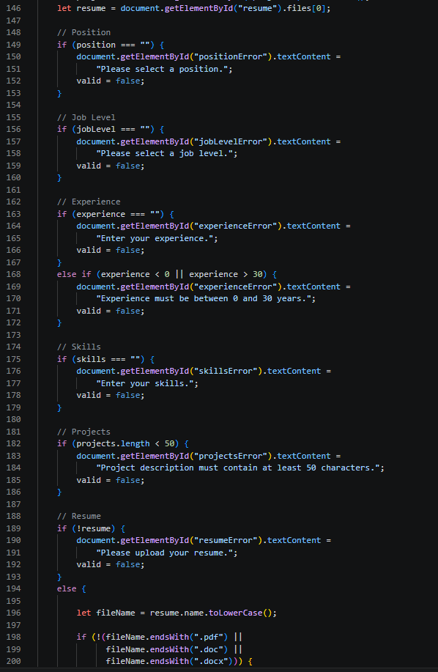
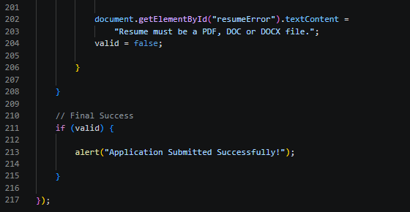

Output:
Registration Form:
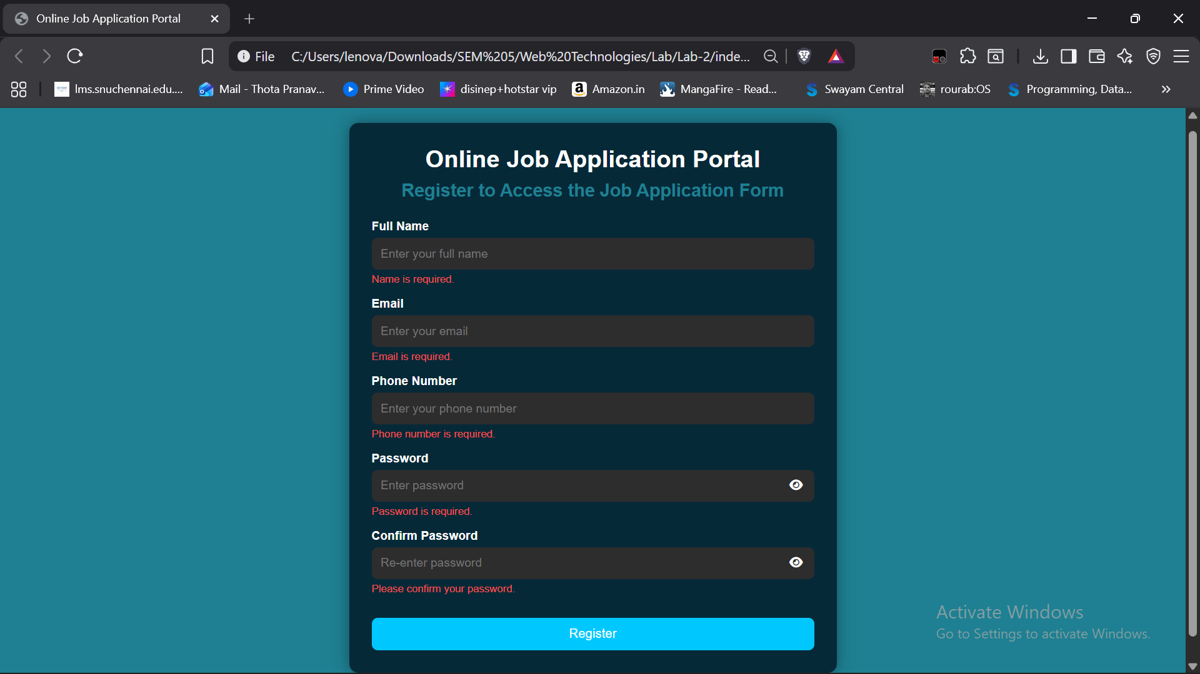

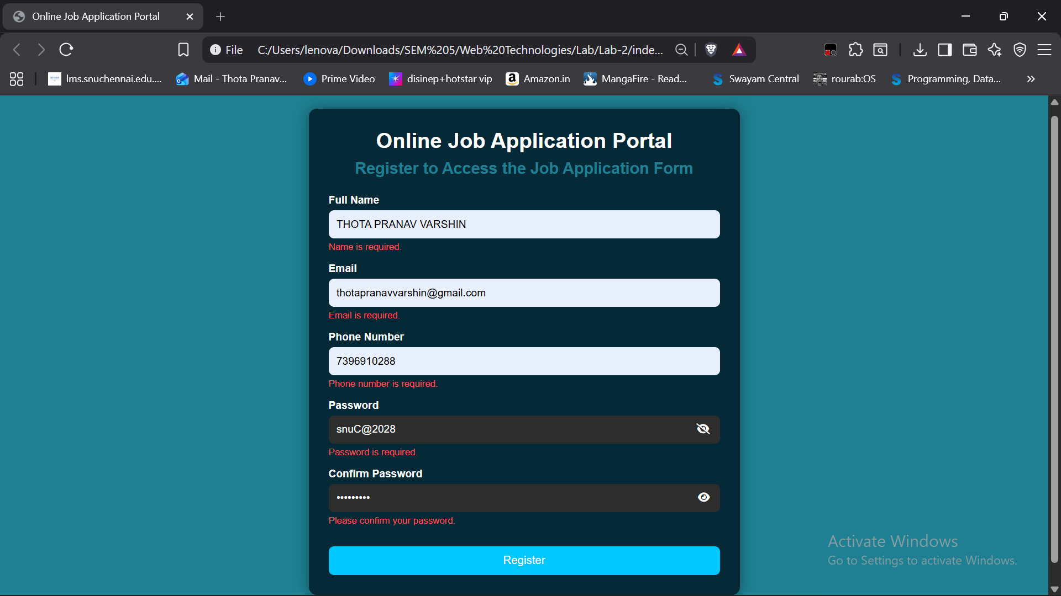
Registered

Proceeds to Job Application Form
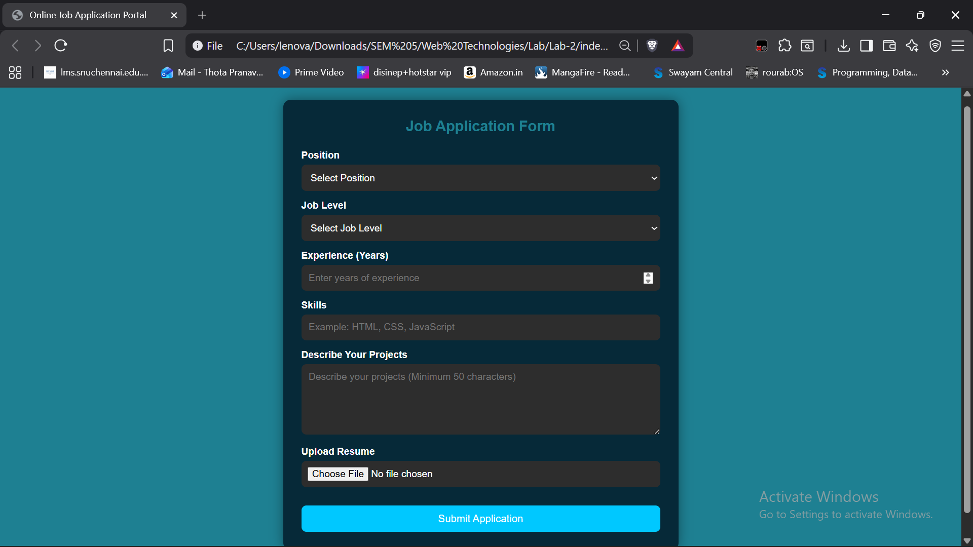

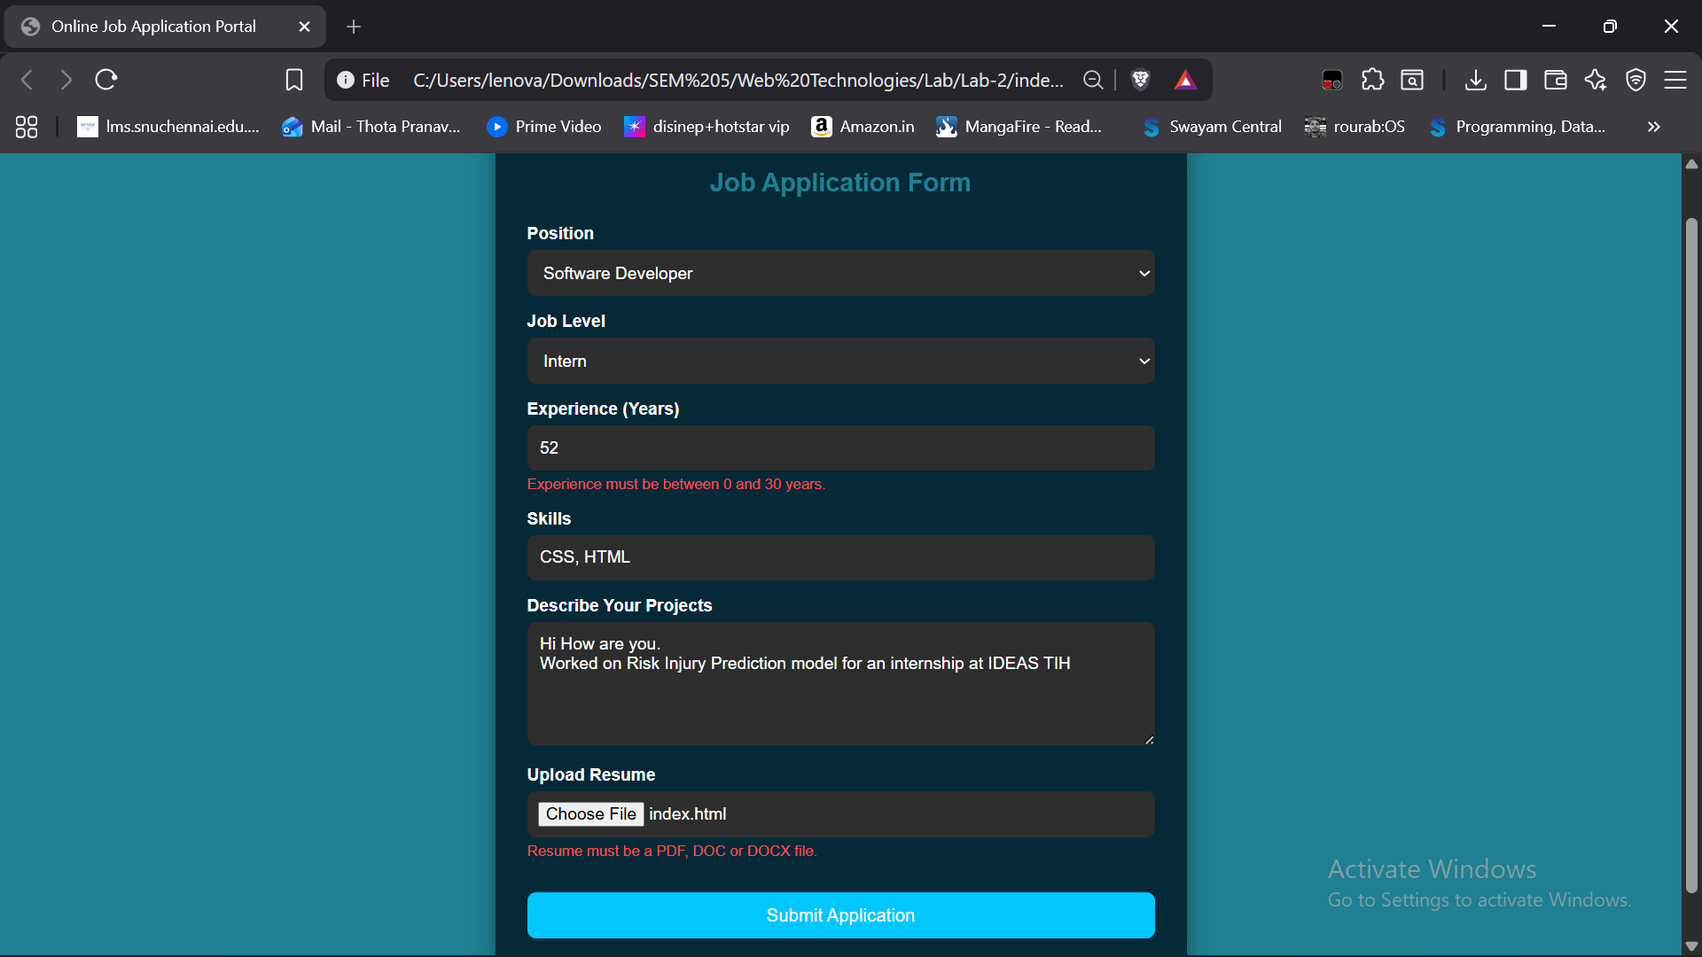
After changing Experience and Resume file
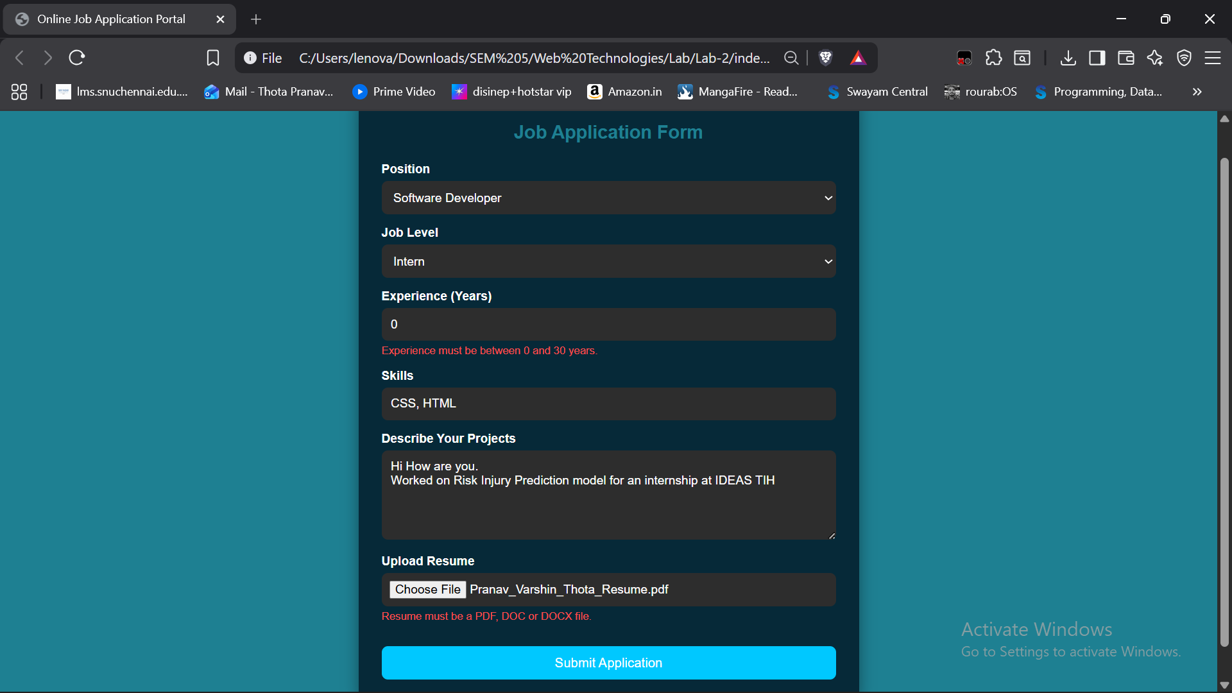
Submitted Successfully
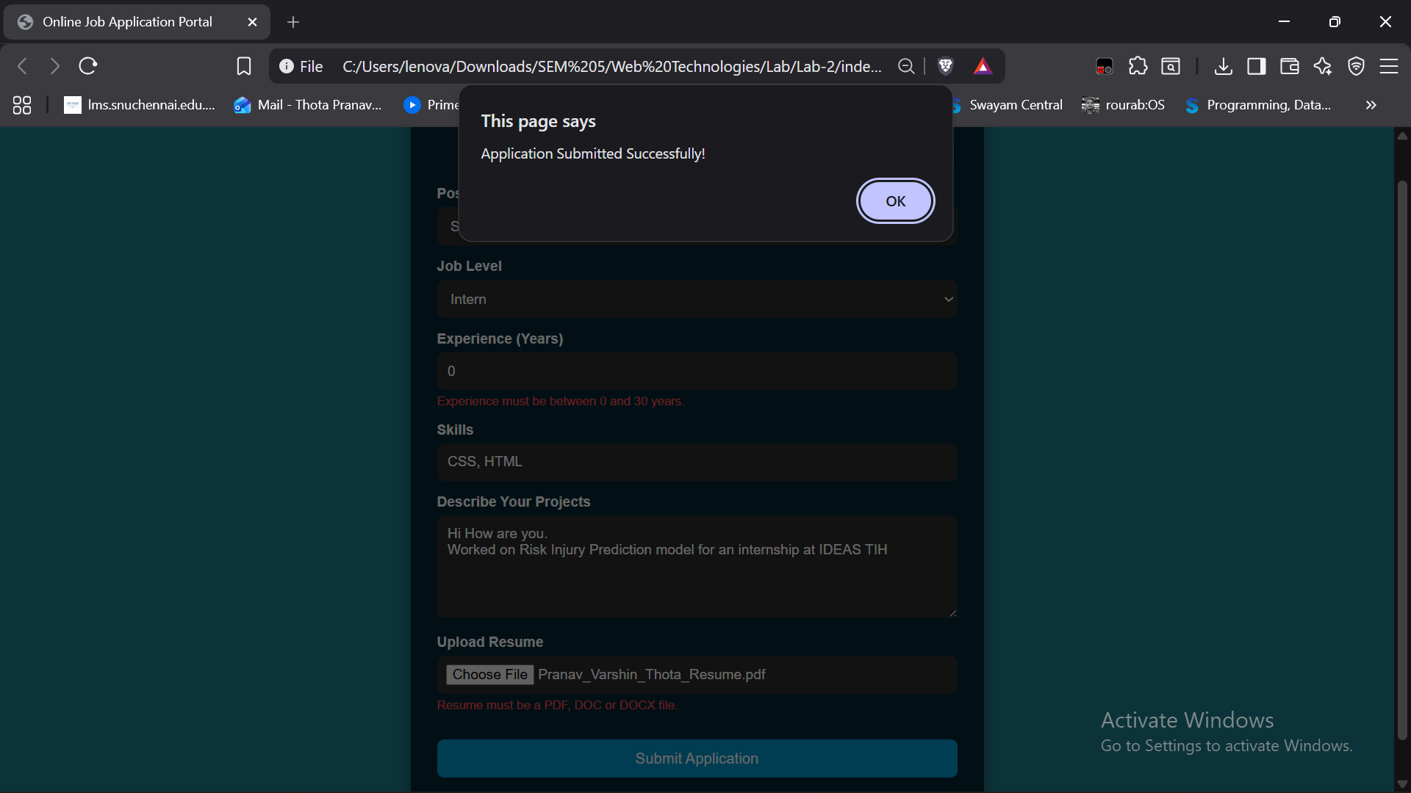
Conclusion:
- Used HTML to structure the web page
- Used CSS to add design to the web page
- Implemented Java Script to add functions such as password toggle, form input restraints and registration and submission for Job Application

T Pranav Varshin (24110413)
24011101116
AI&DS-B

